
Lab no: 17 Date: 2082/01/08
Title: Write a program for finding the shortest path using Dijkstra’s Algorithm.

Dijkstra’s Algorithm:
Dijkstra’s algorithm is a well-known greedy algorithm used to find the shortest path from a single source vertex to all other vertices in a weighted graph with non-negative edge weights. It systematically explores the nearest unvisited vertex and updates the shortest distances. This algorithm is widely applied in routing, navigation systems, and network optimization due to its efficiency and accuracy.

Algorithm:
- Initialize distances from the source to all vertices as infinity, except the source which is 0.
- Mark all vertices as unvisited.
- Select the unvisited vertex with the smallest distance.
- Update the distances of its adjacent unvisited neighbors.
- Repeat the process until all vertices are visited.

Pseudocode:
DIJKSTRA(G, source):
for each vertex v in G:
dist[v] ← ∞
visited[v] ← false
dist[source] ← 0

for i = 1 to |V| - 1:
u ← vertex with minimum dist[u] among unvisited
visited[u] ← true

for each neighbor v of u:
if not visited[v] and dist[u] + weight(u, v) < dist[v]:
dist[v] ← dist[u] + weight(u, v)

Compiler: Dev C++
Language: C

Source Code:
#include<stdio.h>
#include<conio.h>
#define INFINITY 9999
#define MAX 10

void dijikstra(int G[MAX][MAX], int n, int startnode);

int main(){
int G[MAX][MAX], i, j, n, u;
printf("\nEnter the no. of vertices:: ");
scanf("%d", &n);
printf("\nEnter the adjacency matrix::\n");
for(i=0;i < n;i++)
for(j=0;j < n;j++)
scanf("%d", &G[i][j]);
printf("\nEnter the starting node:: ");
scanf("%d", &u);
dijikstra(G,n,u);
return 1;
}
void dijikstra(int G[MAX][MAX], int n, int startnode)
{
int cost[MAX][MAX], distance[MAX], pred[MAX];
int visited[MAX], count, mindistance, nextnode, i,j;
for(i=0;i < n;i++)
for(j=0;j < n;j++)
if(G[i][j]==0)
cost[i][j]=INFINITY;
else
cost[i][j]=G[i][j];
for(i=0;i< n;i++)
{
distance[i]=cost[startnode][i];
pred[i]=startnode;
visited[i]=0;
}
distance[startnode]=0;
visited[startnode]=1;
count=1;
while(count < n-1){
mindistance=INFINITY;
for(i=0;i < n;i++)
if(distance[i] < mindistance&&!visited[i])
{
mindistance=distance[i];
nextnode=i;
}
visited[nextnode]=1;
for(i=0;i < n;i++)
if(!visited[i])
if(mindistance+cost[nextnode][i] < distance[i])
{
distance[i]=mindistance+cost[nextnode][i];
pred[i]=nextnode;
}
count++;
}

for(i=0;i < n;i++)
if(i!=startnode)
{
printf("\nDistance of %d = %d", i, distance[i]);
printf("\nPath = %d", i);
j=i;
do
{
j=pred[j];
printf(" <-%d", j);
}
while(j!=startnode);
}
}

Output:

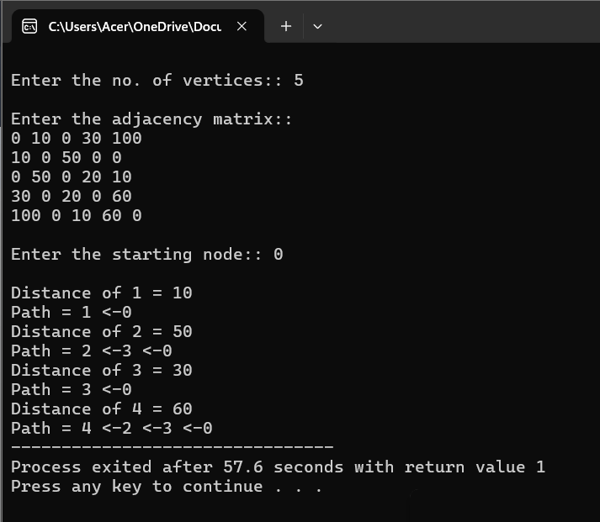


Lab no: 18 Date: 2082/01/08
Title: Write a program for Dynamic Programming-(0/1 Knapsack problem).

Knapsack Problem:
The 0/1 Knapsack problem is a classic example of dynamic programming. It involves selecting a subset of items with given weights and values to maximize the total value without exceeding the weight limit of a knapsack. Each item can either be included (1) or excluded (0), making it a combinatorial optimization problem.

Algorithm:
- Create a 2D table dp[n+1][W+1], where n is the number of items and W is the capacity of the knapsack.
- Initialize the first row and first column of the table with 0.
- For each item i from 1 to n:
  - For each weight w from 1 to W:
    - If the weight of the current item is less than or equal to w, take the maximum of:
      - Including the item: value[i-1] + dp[i-1][w - weight[i-1]]
      - Excluding the item: dp[i-1][w]
    - Else, carry forward the value: dp[i][w] = dp[i-1][w]
- The final answer will be in dp[n][W].

Pseudocode:
KNAPSACK(values, weights, n, W):
Create dp[0...n][0...W] initialized to 0

for i from 1 to n:
for w from 1 to W:
if weights[i-1] ≤ w:
dp[i][w] = max(values[i-1] + dp[i-1][w - weights[i-1]], dp[i-1][w])
else:
dp[i][w] = dp[i-1][w]

return dp[n][W]

Compiler: Dev C++
Language: C
Source Code:
#include <stdio.h>

int max(int a, int b) {
return (a > b) ? a : b;
}

void printKnapsackTree(int W, int wt[], int val[], int n, int level) {
if (n == 0 || W == 0) {
return; // Base case: no items or knapsack full
}

// Print the current state of the decision tree (with indentation for level)
for (int i = 0; i < level; i++) {
printf(" "); // Add spaces for indentation (based on recursion level)
}
printf("Knapsack(%d, {%d, %d, %d})\n", W, wt[0], wt[1], wt[2]);

// Decision tree: include or exclude the item
if (wt[n-1] <= W) {
for (int i = 0; i < level; i++) {
printf(" "); // Add spaces for indentation
}
printf(" |\n"); // Print the arrow to the next decision

for (int i = 0; i < level; i++) {
printf(" "); // Add spaces for indentation
}
printf("Include Item %d\n", n);
printKnapsackTree(W - wt[n-1], wt, val, n-1, level + 1); // Include item

for (int i = 0; i < level; i++) {
printf(" "); // Add spaces for indentation
}
printf(" |\n"); // Print the arrow to the next decision

for (int i = 0; i < level; i++) {
printf(" "); // Add spaces for indentation
}
printf("Exclude Item %d\n", n);
printKnapsackTree(W, wt, val, n-1, level + 1); // Exclude item
} else {
for (int i = 0; i < level; i++) {
printf(" "); // Add spaces for indentation
}
printf(" |\n"); // Print the arrow to the next decision

for (int i = 0; i < level; i++) {
printf(" "); // Add spaces for indentation
}
printf("Exclude Item %d\n", n);
printKnapsackTree(W, wt, val, n-1, level + 1); // Exclude item
}
}
// Recursive function to solve 0/1 Knapsack problem
int knapsack(int W, int wt[], int val[], int n) {
if (n == 0 || W == 0) {
return 0; // Base case: no items or knapsack full
}

// Include or exclude the item
if (wt[n-1] <= W) {
int include = val[n-1] + knapsack(W - wt[n-1], wt, val, n-1); // Include item
int exclude = knapsack(W, wt, val, n-1); // Exclude item
return max(include, exclude);
} else {
return knapsack(W, wt, val, n-1); // Exclude item
}
}

int main() {
int val[] = {60, 100, 120}; // Values of the items
int wt[] = {10, 20, 30}; // Weights of the items
int W = 50; // Knapsack capacity
int n = sizeof(val) / sizeof(val[0]);

// Print maximum value in knapsack
printf("Maximum value in Knapsack = %d\n", knapsack(W, wt, val, n));

// Print the decision tree with arrows
printf("\nDecision Tree:\n");
printKnapsackTree(W, wt, val, n, 0);

return 0;
}

Output:
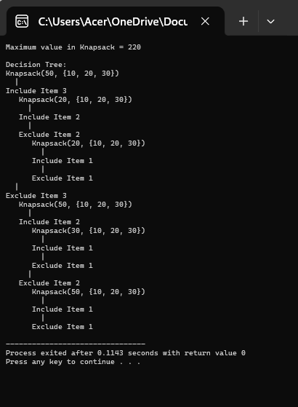


Lab no: 19 Date: 2082/01/08
Title: Write a program for Backtracking Approach(N-Queen Problem).

Backtracking Approach:
Backtracking is a general algorithmic technique used to solve optimization problems, decision problems, and combinatorial problems. It involves exploring all possible solutions incrementally and eliminating those that fail to meet the required conditions. In this approach, a solution is built step by step, and at each step, a decision is made. If at any point, the solution violates any condition, the algorithm backtracks to the previous step and tries a different path.
Algorithm:
- Input: Problem constraints and possible choices.
- Output: The solution to the problem (or an approximation).
Steps:
- Start with an empty solution.
- At each step, choose an option (choice) to explore.
- If the current solution violates any constraints, discard it.
- If a complete valid solution is found, return it.
- Otherwise, backtrack to explore other options.
- Repeat until all possibilities are explored or a solution is found.

Algorithm of N-Queen Problem:
- Place queens one by one in different columns.
- For every row, check if placing the queen violates any conditions (same column or diagonal).
- If placing the queen is valid, move to the next row.
- If all queens are placed successfully, return the solution.
- If no valid position is found for a queen, backtrack to the previous row and move the queen to the next valid position.

Compiler: Dev C++
Language: C

Source Code:
#include <stdio.h>
#include <stdbool.h>
#include <stdlib.h>

int min(int x, int y) { return (x < y)? x: y; }

bool isSafe(int board[], int row, int col) {
for (int i = 0; i < col; i++) {
// Check if the queen is placed in the same row or diagonal
if (board[i] == row || abs(board[i] - row) == abs(i - col)) {
return false;
}
}
return true;
}

bool solveNQ(int board[], int col, int N) {
// Base case: If all queens are placed, return true
if (col >= N) {
return true;
}

// Consider this column and try all rows
for (int i = 0; i < N; i++) {
// Check if queen can be placed on board[i][col]
if (isSafe(board, i, col)) {
board[col] = i; // Place the queen

// Recur to place the rest of the queens
if (solveNQ(board, col + 1, N)) {
return true;
}

// If placing queen in board[i][col] doesn't lead to a solution,
// then backtrack by removing queen from board[i][col]
board[col] = -1; // Backtrack
}
}

// If the queen cannot be placed in any row in this column, return false
return false;
}

void printSolution(int board[], int N) {
for (int i = 0; i < N; i++) {
for (int j = 0; j < N; j++) {
if (board[i] == j) {
printf(" Q%d ", i+1); // Print queen number
} else {
printf(" . "); // Print empty position
}
}
printf("\n");
}
}

int main() {
int N;

// Take input for N (size of the board)
printf("Enter the size of the board (N): ");
scanf("%d", &N);

int* board = (int*) malloc(N * sizeof(int));
for (int i = 0; i < N; i++) {
board[i] = -1; // Initialize the board
}

if (solveNQ(board, 0, N)) {
printf("\nSolution exists: \n");
printSolution(board, N);
} else {
printf("Solution does not exist\n");
}

free(board); // Free the allocated memory
return 0;
}

Output:

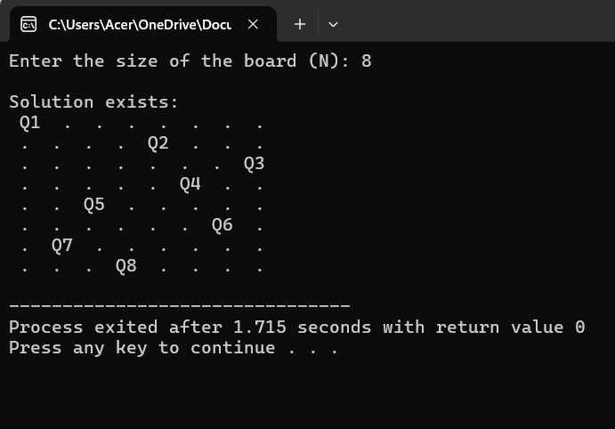


Lab no: 20 Date: 2082/01/08
Title: Write a program for implementing Approximation Approach.

Approximation Approach:

An approximation algorithm serves as an approach to address NP-completeness in optimization problems. While not ensuring the optimal solution, this technique aims to achieve a solution as close as possible to the optimum value within a reasonable timeframe, typically within polynomial time. These algorithms are referred to as either approximation algorithms or heuristic algorithms.

In the context of a graph G, a vertex cover problem involves finding a set of vertices in which each edge in G is connected to at least one of these vertices. The goal is to determine a minimum-size vertex cover for the given graph, referred to as an optional vertex cover C*. The strategy involves iteratively selecting edges (u, v) and adding both vertices to C, subsequently removing all edges incident to either u or v. This process continues until all edges have been addressed.

Algorithm:
- Initialize the result as {}
- Consider a set of all edges in the given graph. Let the set be E.
- Do the following while E is not empty.
  - Pick an arbitrary edge (u, v) from set E and add 'u' and 'v' to result.
  - Remove all edges from E which are either incident on u or v.
- Return result.

Compiler: Dev C++
Language: C

Source Code:
#include <stdio.h>
#include <stdlib.h>

int min(int x, int y) {
return (x < y) ? x : y;
}
struct node {
int data;
int vc;
struct node* left, * right;
};

// Function to print the current node and its children
void printNode(struct node* root) {
if (root == NULL) return;
printf("Node: %d ", root->data);
if (root->left) {
printf("Left Child: %d ", root->left->data);
}
if (root->right) {
printf("Right Child: %d ", root->right->data);
}
printf("\n");
}

// Function to calculate the vertex cover and print intermediate steps
int vCover(struct node* root) {
if (root == NULL)
return 0;
if (root->left == NULL && root->right == NULL)
return 0;

if (root->vc != 0)
return root->vc;

// Display the current node being considered
printNode(root);

// Calculate the vertex cover including and excluding the current node
int size_incl = 1 + vCover(root->left) + vCover(root->right);
int size_excl = 0;
if (root->left)
size_excl += 1 + vCover(root->left->left) + vCover(root->left->right);
if (root->right)
size_excl += 1 + vCover(root->right->left) + vCover(root->right->right);

root->vc = min(size_incl, size_excl);
return root->vc;
}

// Function to create a new node
struct node* newNode(int data) {
struct node* temp = (struct node*)malloc(sizeof(struct node));
temp->data = data;
temp->left = temp->right = NULL;
temp->vc = 0;
return temp;
}

int main() {
// Construct the tree as per the example
struct node* root = newNode(20);
root->left = newNode(8);
root->left->left = newNode(4);
root->left->right = newNode(12);
root->left->right->left = newNode(10);
root->left->right->right = newNode(14);
root->right = newNode(22);
root->right->right = newNode(25);

// Print input values (tree structure)
printf("Tree Structure (input values):\n");
printf("Root: %d\n", root->data);
printNode(root->left);
printNode(root->right);
printNode(root->left->left);
printNode(root->left->right);
printNode(root->left->right->left);
printNode(root->left->right->right);
printNode(root->right->right);

// Calculate and print the size of the smallest vertex cover
printf("\nSize of the smallest vertex cover is %d \n\n", vCover(root));

return 0;
}
Output:
